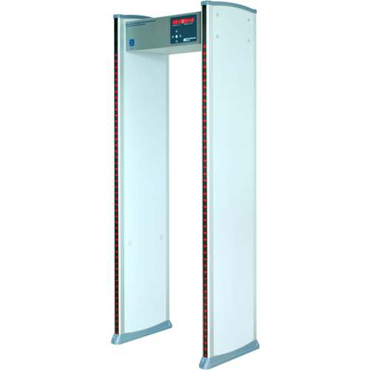

USER MANUAL OF XLD-A
WALK THROUGH METAL DETECTOR

PLEASE READ THE FOLLOWING INSTRUCTION CAREFULLY BEFORE OPERATON
Regarding to how to how to use the machine correctly and safely, please attention to the following instructions. make sure you have read it before operation.
1. It’s available for both indoor and outdoor use, please use canopy to protect it against rain.
2. Choose the smooth and stable installation place, don’t touch the detector during security checking to avoid false alarm.
3. Make sure there’s no big metal object or strong magnetic field around the detector within 2 meters.
4. Keep the detector far from the power line and communication cable.
5. Detector probe must not install in high temperature or wet circumstance.
6. Do not disassemble the control units except the professional technician.
7. Please wait l minute for its self-diagnosing when machine start.
8. We advise to have a power cord on the ceiling, easier to connect to the detector.
9. Follow the user manual and make sure the right wire connection when machine start.

1
【PRODUCT SPECIFICATION】
XLD digital Walk Through metal detector adopts international advanced digital detection technology, specifically used for detecting and preventing the metal and alloy materials hidden on human body. High security,applicability, and high sensitivity,wide range of detecting and strong anti-interference, can 24-hour intelligence service, sound and light alarm at the same time, quality, effectiveness, technical parameters all reach the world advanced level. The sensitivity can be adjusted, the highest sensitivity could detect the metal size such as paper clips and distinguish the zone where the metal hidden, the user also could reset according to the size,Measurement, weight of the metal excluded the coin, key, jewelry, belt buckle in case false alarm. For the place where need to prevent losing the precious metal materials, such as industrial and mining enterprises, bank, private mansion etc, and the place where need to prevent the carrying of dangerous goods, such as Airport, prisons, customs and exhibition hall, it’ll be your wise choice for installing the SUNLEADER walk through metal detector.

2
【WARRANTY CARD】
1. Please keep this card with reasonableness, and show it when maintaining it.
2. This card will be invalid if without the signature or stamp of the designated dealer.
3. This card will be regarded as invalid if it has not been filled in details three guarantees and acknowledgment of receipt, please confirm whether the data filled in the three guarantees and acknowledgment of receipt is correct or not when purchasing it, and then hand it over to the dealer.
4. This card will not be supplied again if losing it.

Product type
Product number
Date acquisition
User(Liaison)
Post code
Address
User’s phone number
Fax

Date of maintenance | Record of maintenance | Maintainer

15
【BRIEF MAINTENANCE】
1. Can’t Start The Machine
1) Check whether power sockets properly.
2) Check whether the power switch is on.
3) Check the fuse blew out (Only for Walk Through model).
2. Can’t Account Passengers
1) Don’t work in the strong sunlight as it use infrared sensor.
2) Check the left and right infrared sensor probe whether in parallel.
3. Alarm Without Metal
1) First, exclude all the metal in ourself and go through the detector. Find out which zones alarm and low down the zone sensitivity accordingly until it is not alarm.
2) Check whether have interference nearby such as big movable machine, high-power equipment.
3) Check whether there are similar products nearby, if so change the frequency(Original frequency show on the package carton box).
4) Make sure no big wind and smooth around installation place.
4. With Metal But No Alarm
1) Follow the user manual and increase the zone sensitivity and total sensitivity.
2) The factory default setting can detect a coin diameter 25mm. Make sure the metal size is bigger,if not adjust the sensitivity accordingly.
5.Single Zone No Alarm
Make higher sensitivity then test again.Change the corresponding zone signal collection card if problem is the same in highest sensitivity.
6. Unnormal Communications
1) Follow the user manual and confirm whether is the problem of left sensor or right sensor.
2）When confirmed which door frame have communication problems, pull out its probe and reinsert for several times,then test again. If problem the same, then replace the corresponding signal collection card, main board and wire step by step until confirm the problems.
7. Whole Machine Non-inductivity
- Check whether the communication is ok, follow above 6 steps.
- If communication is ok, replace the mainboard or signal board step by step.
8. LCD Screen Problems, LED Bar Graph Not Lighting,Buttons Not Working
1) Replace the parts from other Walk Through metal detector to find the failure parts

14
【INTERFERENCE】
The interference during the walk through metal detector working,are mainly as follow:

Electronic Jamming
Working frequency for the Walk Through metal detector is 4KHz-8KHz. around the work environment should exclude the electronic products that have the almost similar working frequency such as generator, TV etc.

Moving metal objects Interference
The Walk Through metal detector will be interfered by the moving metal objects, around the work environment should not have turnstile and from vehicle etc. big moving metal objects.

Interference Between Products And Products
During using 2 pieces or more Walk Through metal,should avoid using the same frequency(the work frequency can be seen on the packing box),the minimum distance between two doors should be above 0.7m to avoid the mutual interference for the Walk Through metal detectors.

3
【INSTALLATION INSTRUCTIONS】

PRODUCT ASSEMBLY

Figure I

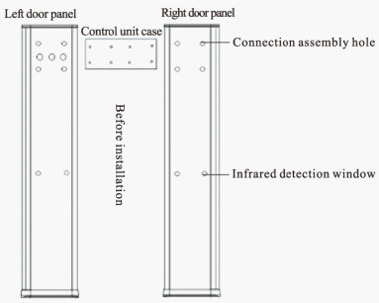

4
【OPTIONAL ACCESSORIES】
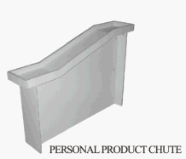



【PACKING LIST】

Thanks you very much for buying our Walk Through metal detector.
Please check and ensure the following parts are complete, if there is anything lost or damaged, please feel free to contact us.

POWER CABLE,SCREWS
HEXAGON WRENCH
CERTIFICATION OF QUALITY
WARRANTY CARD
WARNING STICKERS
USER MANUAL

13
【TECHNICAL PARAMETERS】

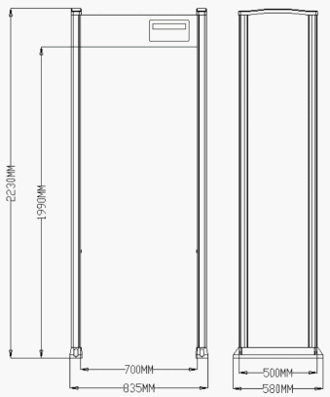

Electric Current: AC85-264V/47.5-60Hz
Power: ＜20W Workplace environment -20℃≈+50℃
Package: two cartons/unit
Net Weight: 70kg
Standard: GB15210-2003,CE
Inner Dimension: 1990(H)X 700(W)X 500(D)mm
External Dimension: 2230(H)X 835(W)X 580(D)mm
(Size is with real products accurate, can be customized)

12
【INSTALLATION INSTRUCTION】

Figure II

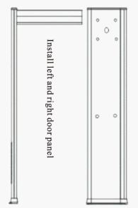

5
【INSTALLATION INSTRUCTIONS】

Figure III

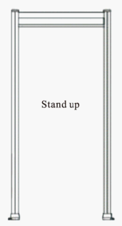
As shown above, keep the door panel flat on the bubble, take the joint screws, then first connect the control unit case and the left door panel with screws, and then connect the right door panel with the control unit case, after they are ready, lock the cover of the control unit case and then make the Walk Through metal detector erected.

6
【PRODUCT GUIDE】

F--1 7800

Figure 7
7. Setting Password
The panel display P---1234 (FIgure8), Press ENTER key enter into the interface of advising password (Figure 9), press Upward/Downward Key to increase/reduce the number, press LEFT/RIGHT key to make the left and right optional among the numbers, after the after the password is advised ready and then press ENTER key to save the new password, Then all is setting ready and the detector enter into normal working state.
The specific method for setting passing word is as follow(only 4 numbers for password)as Figure 10, the left 4 numbers are old password, the right 4 numbers need to be set and will be used, so only put into the left 4 numbers correct and then the right 4 new password numbers can be be set successful.
P--- 1234

Figure 8

0000 0000

Figure 9

11
【PRODUCT GUIDE】
4. After setting the 6 zone’s sensitivity, press ENTER key saving the value of the sensitivity and enter in to the interface of alarm setting, the panel display Figure 5, The A-1 means Volume setting , 1 means alarm volume, the scope of volume is from 0-255, the bigger volume value the higher alarm sound; when the volume is 0, it’s no sound then. During setting the volume, press Upward or Downward key until sound the prefect alarm sound and then press ENTER key to save.
A--1 1

Figure 5

5. Alarm Session-timeout Setting
The panel display A--2 01 (Figure 6), The A--2 means session-timeout setting , the 01 means alarm time, the scope for alarm time is 0-25s. Press Upward/Downward key for setting it, press Left key to exit. After adjustment, please press ENTER key for saving data and return back the interface of alarm session-timeout setting.
A--2 01

Figure 6
6. Working Frequency Setting
The panel display F1 7800 Figure 7, the F-1 means working frequency setting, the 7800 means working frequency, the scope for working frequency is 4-8KHZ, press ENTER key enter into Working frequency setting, press Upward/Downward key to adjust and press LEFT key to exit. Press ENTER key for saving data and return back to the interface of working frequency setting.

10
【KEYPAD FUNCTION SPECIFICATION】

XLD-A
Figure IV

As the keypad layout of Figure IV,the function specifications are as follow:
Enter: startup and close,enter the option.
Left key: left option, return, parameters to be the left or upward options.
Right key: right option, parameters to be the right or downward options.
Upward key: upward option,parameters to be incremental adjustment.
Downward key: downward option, parameters to be reduction adjustment.
The specific function, please reference keypad operating instructions in the relative setting pages.

7
【PRODUCT GUIDE】
Plug the power first, open the switch below the door panel and the switch light shine, said external power supply good. Press ENTER KEY 3 seconds for opening the power(The same theory when close the power)enter into the normal working state, the panel of the control unit case will display the passing times and alarm times as Figure 1.

0000 0000

Figure 1

1. Under the normal working state,Press ENTER key,put into initial password (Figure 2).
The upward and downward key adjust the number, the Left and right key switch between different bits.

9000 0000

Figure 2

8
【PRODUCT GUIDE】
2. Press ENTER key, confirm the password and enter into menu setting. Then the panel shows H--0070 Figure 3. The H--X,X means X Zone sensitivity, 0 means whole sensitivity, 070 means this zone’s sensitivity, the scope is from 0-255, This equipment is used for setting a whole alarm value, it can set according to the requirement, the bigger number the higher sensitivity, when set H-0 0 means closing the detecting sensitivity, then all detecting zones will not alarm. Press ENTER key enter into adjusting, press Upward and Downward key to adjust the sensitivity value, press Left key to exit adjusting the whole sensitivity, after adjusting the sensitivity value, press ENTER key to save and return back to the interface of setting whole sensitivity, Press DOWNWARD key enter into setting the sensitivity of NO.1 zone.
H--0 070

Figure 3
3.Setting the sensitivity of NO.1 zone, press ENTER key enter into the interface of setting the sensitivity of NO.1 zone (Figure 4), press upward and downward key to adjust the sensitivity value, press LEFT key to exit advising the NO.1 zone sensitivity, after adjusting the sensitivity value, press ENTER key to save the value and return back to the interface of setting each zone’s sensitivity, Press Upward/Downward key enter into setting the each zone’s sensitivity.
H--1 070

Figure 4

9

